**Lesson 6: Is It Important to Know Where Our Food Comes From: Science Fiction vs. Real Life**

**Overarching Question: why is understanding our food pipeline critical?**

**Note to teachers:**  Talking about science fiction film and literature in science is a novel way to introduce a new concept that reaches out to the students who usually are relatively marginalized in a traditional biology class. These are the kids you see with their nose poked in books while you are delivering the best lesson of your life! ☺ To them, the ‘facts’ of biology are boring because these students perceive that there are too many constraints on their imagination by facts alone. But, if you move biology into a realm of science fiction and fantasy, these students come alive and actively engage in thinking about science in a new way. How do I know? I was one of those kids! ☺

**Introduction:**  One of the favorite topics of science fiction writers from the 1950’s through the 1990’s was the topic of human overpopulation and what happens when humans have exceeded the carrying capacity of the Earth and can no longer feed themselves. The idea of unsustainable growth of humans and the killing off of our planet spawned a genre of films that predicted dire consequences for people if they lost hold of their knowledge of and control over their food supply chain. Such films as Logan’s Run and Soylent Green showed audiences vivid scenes of what happens when society gives up control and knowledge of their food sources, as well as what happens to those who questioned that status

**Materials:**copy of film Soylent Green, copy of BiteLab article (attached)

**Lesson Part 1:**Read the article to them on BiteLab.

1. Hold a discussion around this article; do they think it’s real? Can science do that now? Is this considered a GMO? Is this ethical? Is the idea a potential solution to not enough food? What would a food supply chain look like? Where would this fit in on our causal loop diagram? Would people actually do it? These are all questions that have been explored before, and have been the fodder of science fiction literature and film for a long time.
2. Pose the question:  Does science fiction mirror our future or our fears? (discuss)

**Lesson Part 2:  *(****Students should respond to these questions in lab notebooks)*

Show the film Soylent Green. You will have to walk students through the clues in the movie because they are not used to having to watch carefully and piece clues together.

1. Pose the question again: Does science fiction mirror our future or our fears? Examples of sci-fi come true; Arthur C. Clarke wrote about satellites in 1945, well before any satellites were ever launched and was questioned by the military. George Orwell in his book, 1984, wrote about cameras watching the movements of citizens and everyone thought he was paranoid and delusional. We now have cameras everywhere and think nothing of it.
2. Should we care about our food supply chain? Why or why not? Other supply chains we care about: diamonds (legitimate mines vs. blood diamonds), clothing (us made by union workers vs. foreign made by slave children), oil (North American oil vs. Arab oil)
3. Who are the stakeholders in a food supply chain? (review)
4. What happens to the food security and food supply chain if one of the nodes or edges is disrupted or perturbed?
5. Can we develop a home or classroom system that could help us become little more sustainable? What about hydroponics? What about aquaponics?

**HERE IS YOUR INTRODUCTION TO BUILDING A CLASSROOM AQUAPONIC UNIT!!!!**

**Formative Assessment:**

1. Students should write answers to Questions 1-5 in lab notebooks. Check notebooks for ideas and thoughts that pertain to a growing understanding of the food system.
2. Ask students to write a reflection on what they think would make a good system, given the many disruptions to the system that could occur.
3. What are the resources we need to consider in designing this system?

**BiteLabs website claims to grow 'meat' from celebrity tissue samples**

Date: February 27, 2014

**Lily Hay Newman**

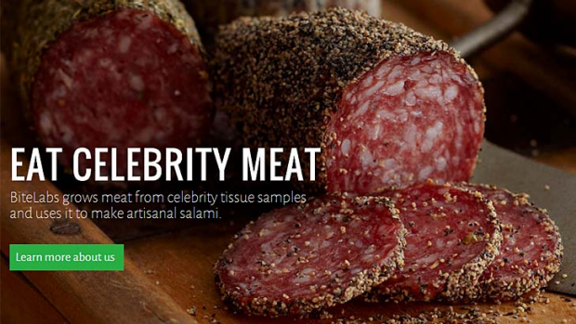

The stuff of nightmares: The BiteLabs website.

A lot of weird stuff shows up on the internet, but Bite Labs is really, *really*weird. The website claims to be collecting tissue samples from celebrities, isolating the muscle stem cells, growing celebrity meat in "proprietary bioreactors" and then turning it into "artisanal salami".

"We mix celebrity and animal meats, grown in house through a proprietary culturing process, into cured salami blends," says the [BiteLabs](http://bitelabs.org/) website.

"Our process yields high-quality, luxury protein, in a sustainable manner that eliminates the environmental and ethical concerns associated with traditional livestock production."

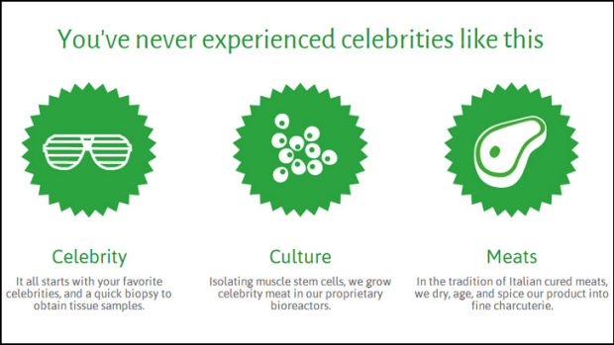

More madness from the BiteLabs website.

No obvious ethical concerns here. Nothin' to see. This must be a hoax, right? Or a marketing campaign that wants to go viral (in which case we're helping). So far the [BiteLabs Tumblr](http://eatcelebritymeat.tumblr.com/) isn't revealing much. Neither is [#EatCelebrityMeat](https://twitter.com/search?q=%23EatCelebrityMeat%20&src=typd).

According to "Kevin" from the BiteLabs team the site is partly a commentary on food culture, the ethics of meat, and "the way celebrity culture is consumed". But the part about making celebrity meat is real, apparently.

"To develop Celebrity Meat, we're working with a group of bio-engineers and food designers, most of which have requested to remain anonymous due to the controversial nature of the product," he said.

"At the moment, I believe Jennifer Lawrence and James Franco are pretty neck and neck in terms of who has been tweeted at the most. We've gotten some responses from people offering us biopsies, but no one on the level of our big four yet. Most of the responses have been very positive, but of course some people are a bit uncomfortable with idea of BiteLabs – we think that's only to be expected when we talk about pushing the boundaries of tech and society."

The group is using ThunderClap for marketing, which means that when they generate enough buzz, ThunderClap will do a timed Facebook and Twitter blast to "create a wave of attention".

Kevin told [*Motherboard*](http://motherboard.vice.com/read/the-guy-who-want-to-sell-you-salami-made-out-of-james-franco-are-100-serious) that "the product is indeed salami", and that each one will have about 30 per cent celebrity meat and 40 per cent lab-grown animal meats along with fat and spices.

When pressed for further details on the wacky project, Kevin refused to elaborate, signaling that this start-up is either top-secret or totally fake.

Some people are suggesting it parodies the look and exuberance of start-ups.

Pitch-perfect parody of contemporary startup, right down to web look and feel. [#eatcelebritymeat](https://twitter.com/search?q=%23eatcelebritymeat&src=hash)!

Others are pointing to the viral marketer [ThunderClap](https://www.thunderclap.it/?locale=en) for some reason. And note that ThunderClap actually favorite’d one of these tweets.

[@ThunderclapIt](https://twitter.com/ThunderclapIt) Seriously, though. [#EatCelebrityMeat](https://twitter.com/search?q=%23EatCelebrityMeat&src=hash)? At least offer me some prime cuts of Ryan Gosling or something.

Or it could just be the North Korean government's plan to resolve food shortages while proving to the world that the oligarchy can compete in the competitive start-up world. Whatever it is, the whole concept has kind of tarnished salami forever, which is a damn shame.